HTML5 & CSS3

# Notes

* <!DOCTYPE html>
  + Instruction to the browser about what version of HTML the page is written in.
  + in this case it is HTML 5
* HTML is content. CSS is style.
* DIV - stands for DEVIDE. We use it simply to divide our page into sections by creating boxes where we put our contents in.
* By default, all elements are 'relative' positioned elements. That means that their position on the Web page is determined by other elements.
* Elements with 'absolute' position can be positioned anywhere we want inside their parent elements. We just have to ensure that the parent element is relative and that the absolute element has a position property set to absolute.
* float property is used to keep 'block' elements side by side.
* Google announced that mobile friendly websites will be ranked higher on their Search Results page.
* Typography is the art and technique of arranging type to make written language readable and beautiful.
* When we make an element with absolute position we have to ensure that its parent has a relative position, and if we didn't do this, this wouldn't appear where we want it.

# Some Design and Typography Tips -

1. Use a font size between 15 and 25 pixels for body text.
2. For headlines and titles, you can and should, of course, use bigger font sizes to show that it's important text that you really want the user to read.  
   There are no real size limits for headlines, like this one.  
   Sometimes when you use such a big headline, you will want to decrease the font weight of that text.   
   This ensures that the text doesn't steal too much attention from the rest of the content. And it makes the text look less bulky and more modern and elegant.
3. Use a line spacing between 120% and 150% of the font size. Line spacing is the vertical distance between lines and makes text easier to read.
4. 45 to 90 characters per line is the optimal line length that is easy to read.
5. The most important thing is probably to choose good-looking fonts.

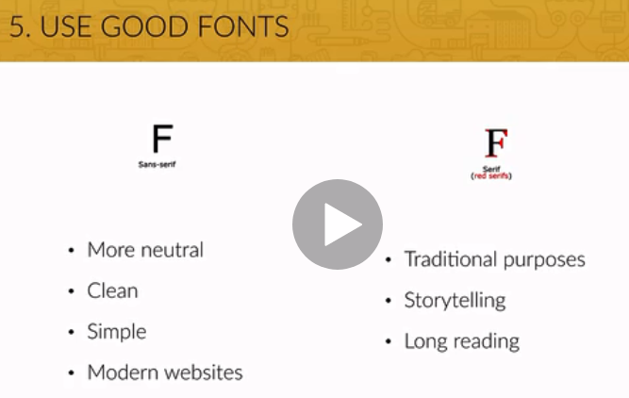

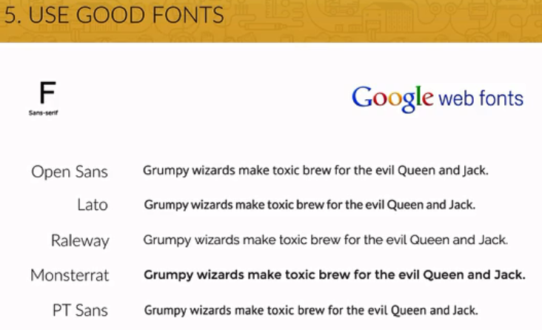

# Fonts

* Google fonts is a very good free resource, where you can get web fonts.
* And web fonts are fonts that you can include directly into your projects without having to download any files.

# Colors

* Use a single base color for your design. Base color means any different color than black, white or some shade of grey.  
  <https://flatuicolors.com/>
* A color palette shows all the colors to be used in a certain design.
* 0To255 is a tool to create darker and light tones for a given color.  
  <https://www.0to255.com/>
* Use a tool if you really want to mix up multiple colors like Adobe Color CC or Paletton.  
  <https://paletton.com/>
* Use color to draw attention – When you're in doubt about using colors and don't know where to use colors and how often, just pick a color that stands out and use it mostly to draw attention to a button or any other element of importance on your website
* Never choose the black color for any part of your design. This is because black actually almost never appears in the real world. So using complete black just doesn't feel natural.
* Choose colors wisely. That's because picking a color for a website means much more than picking your favorite color and turning it into a design. It means picking the right color in order to get the desired response from your audience.

Color really makes a difference. This happens because there are psychological effects behind each color.

Here is how –

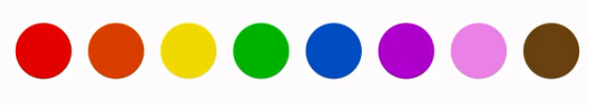

* Red is a great color to use when power, passion, strength and excitement want to be transmitted. Brighter tones are more energetic and darker shades are more powerful and elegant.
* Orange draws attention without being as overpowering as red. It means cheerfulness and creativity. Orange can be associated with friendliness, confidence, and courage.
* Yellow is energetic and gives the feeling of happiness and liveliness. Also, it associates with curiosity, intelligence, brightness, etc.
* Green is the color of harmony, nature, life and health. Also, it is often associated with money. In design, green can have a balancing and harmonizing effect.
* Blue means patience, peace, trustworthiness, and stability. It is one of the most beloved colors, especially by men. It is associated with professionalism, trust and honor. That's actually why the biggest social networks use blue.
* Purple is traditionally associated with power, nobility and wealth. In your design, purple can give a sense of wisdom, royalty, nobility, luxury, and mystery.
* Pink expresses romance, passivity, care, peace, affection, etc.
* Brown is the color of relaxation and confidence. Brown means earthiness, nature, durability, comfort, and reliability.

# Working with Images

Using large background images can make your website look more attractive and create more user engagement. It has actually been found that image heavy websites convert better.

Effectively put text over images.

1. Put text directly on an image.

* The problem is that this only works if the image is quite dark and your text is white. Otherwise you will not have enough contrast between your image and your text.
* The easiest solution to this problem we saw before is to overlay the image with a color.

The most usual and over course simple to use color is black which simply turns the image darker.

But we can also use other colors as well, and create some beautiful effects with them.

We can use color gradients to achieve stunning effects.

* Use image overlay with colors, other than black or white very carefully.

1. Simply putting the text in a box is another easy way to make your text stand out and easy to read. The box should be opaque so that you can still see the image beneath it.
2. Yet another solution to put text on an images is image blur. And this is very powerful and also very good looking in my opinion. You can either blur the whole image or you can use an out-of-focus area of a photo as the blur.
3. The Floor Fade – The floor fade is a technique where an image subtly fades towards black at the bottom with white text written over it. The floor fade increases the text readability dramatically.  
   In situations where we want text at the bottom of an image, this is the perfect solution to go for.

# Working with Icons

Icons improve the aesthetic of a web site and can provide a better user experience, if well used.

Icons can also cause user confusion when poorly used.

1. We can use icons to show features of your web site or a product that you're selling, or steps that a user should follow to achieve some goal. This is a powerful, modern, and beautiful way of showing what your site has to offer. Icons actually help the user to quickly browse through a page and get an idea what the web site is all about.
2. Instead of showing features, you can use icons for actions and links. Follow these two rules if you are going to do so –
   1. Icons should be instantaneously recognizable and remove open interpretation.
   2. Label your icons if you have enough space to do so.
3. Whatever you do with icons, they should not take a center stage in your design.   
   Instead, they should play a supporting role.
4. Use **icon fonts** whenever possible.  
   There are two types of icon formats: Icons in form of images and icon fonts.   
   Icon fonts use smooth, vector images instead of common roster images to display icons on your web site. It is strongly recommend you to use icon fonts for web design whenever possible.   
   And that's because vectors scale endlessly up or down for any resolution and don’t blur.  
   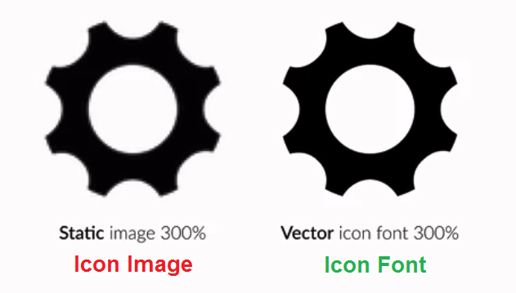

# Spacing and Layout

Whitespace is just space where there isn't any stuff.   
Whitespace absolutely is the key to create a clean and simple look and feel.

The space between the icons and the text, the space between sections, between the section's headings and its content, and between paragraphs makes the web site look clean and inviting, if we use whitespace in a well-executed way.

1. Use Whitespace
   1. Just put whitespace between your elements.
   2. Put whitespace between your groups of elements.
   3. Put whitespace between your web site's sections.
   4. But don't exaggerate. Because when elements are spaced out too much, they may lose the relationships to one another. So don't use too much whitespace.
2. Define Hierarchy  
   With the whitespace that you add, you describe invisible relationships between the elements of your web site. You communicate how the pieces of information relate to one another, and this is very important. So whitespace is closely related to something we call visual hierarchy. This is the organization of your content.  
     
   Hierarchies give your web site order, and so it's kind of important that you get it right.  
   Guidelines -
   1. Define where you want your audience to look first.
   2. Establish a flow that corresponds to your content's message.

Because hierarchy is exactly that. It guides the user from one element to the next.

* 1. Use whitespace to build that exact flow.

# User Experience

Designing the **user interface** means to design the presentation of a product, like a web site or a mobile application. It's designing the look and feel of the product.

**User experience** is the overall experience that the user has with a product. User experience includes the user interface, but also has to understand the whole picture of the product. In short UX simply means how it works.   
*"'It's not just what it looks like and feels like. Design is how it works." – Steve Jobs.*

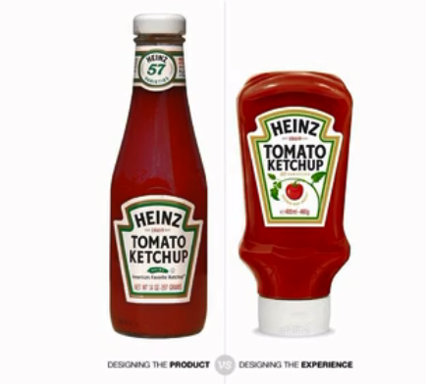

We can think of user experience in terms of user's goals and business' goals. A user experience designer needs to align those goals so the business benefits when the user reaches their goal.

# Inspiration

Inspiration is absolutely essential. You should use other websites as inspiration in order to see what other leading designers are doing right.

Some steps –

1. Collect a bunch of designs that you like and that you think are well-designed.
2. Try to understand everything about them by answering those questions.
3. Why do they look good?
4. What do these sites have in common?
5. And how were they built in HTML and CSS? (Use Google Chrome Developer Tools)

Steal like an artist. ☺ Make your design similar to webpages you like, at least at first. Once you're getting better and better, then originality will come automatically.

# The ultimate cheatsheet: all web design guidelines in one place

## Beautiful Typography

1. Use a font-size between 15 and 25 pixels for body text.
2. Use (really) big font sizes for headlines
3. Use a line spacing between 120 and 150% of the font size
4. 45 to 90 characters per line
5. Use good fonts
6. Chose a font which reflects the look and feel you want for your website
7. Use only one font

## Using Colors Like a Pro

1. Use only one base color
2. Use a tool if you want to use more colors
3. Use color to draw attention
4. Never use black in your design
5. Choose colors wisely

## Working with Images

1. Put text directly on the image
2. Overlay the image
3. Put your text in a box
4. Blur the image
5. The floor fade

## Working with icons

1. Use icons to list features/steps
2. Use icons for actions and links
3. Icons should be recognizable
4. Label your icons
5. Icons should not take a center stage
6. Use icon fonts whenever possible

### Spacing and layout

1. Put whitespace between your elements
2. Put whitespace between your groups of elements
3. Put whitespace between you website's sections
4. Define where you want your audience to look first
5. Establish a flow that corresponds to your content's message
6. Use whitespace to build that flow

# Steps for Building a Website

## 1. Define your project

* Start off by defining the goal of your project. This can be showing your portfolio to the world, selling an e-book, building a blog, etc.
* Also define your audience. Ask yourself: which is the typical user that will visit my website?
* This is important, because you should always design with your goal and audience in mind.

## 2. Plan out everything

* Once your project is defined, plan your content carefully. This includes text, images, videos, icons, etc.
* Remember what I told you about visual hierarchy. It plays an important role when you start thinking about what you want on your website and what you don't. Defining the content before actually starting the design is called the content-first approach. It means that you should design for the content, instead of designing a webpage and then filling it with some stuff.
* Define the navigation.
* Define the site structure. You can draw a sitemap in this step if we're talking about a bigger project.

## 3. Sketch your ideas before you design

* Now it's time to get inspired and think about your design.
* Then, get the ideas out of your head. And with that I mean that you should sketch your ideas before you start designing. It will help you explore ideas and create a concept of what you want to build. Using pencil and paper is a great way of quickly retaining your valuable ideas.
* Make as many sketches as you want, but don't spend too much time perfecting anything. Once you have an initial idea, you can concentrate on the details when designing in HTML and CSS.
* I advise you to never, ever start designing without having an idea of what you want to build. Getting inspiration is very important in this phase, and I already told you how to do that!

## 4. Design and develop your website

* After sketching, start to design your website using all the guidelines and tips you've learned in the web design section.
* You'll do that using HTML and CSS, which is called designing in the browser. Designing in the browser is basically designing and developing at the same time.
* There are more and more designers leaving traditional design programs such as Photoshop and start designing in the browser. The biggest reason for this is that you can't design responsive websites in photoshop. It also saves you tons of time.
* In this phase, you'll use your sketches, content and planning decisions you've made in steps 1, 2 and 3.

## 5. It's not done yet: optimization

* Before you can actually launch your beautiful masterpiece for the world to see it, we have to optimize its performance in terms of site speed.
* You also need to do some basic search engine optimization (SEO) for search engines such as Google.

## 6. Launch the masterpiece

* Your optimized website is now finally ready to launch.
* All you need for launching is a webserver that will host your website and deliver it to the world.

## 7. Site maintenance

* The launch of your website is not the end of the story.
* Now it's time to monitor your users' behavior and make some changes to your website if necessary.
* You should also update your content regularly in order to show your users that your website is alive! For instance, a blog can be a great way of doing that.

# Three main ingredients to responsive web design.

1. Fluid Grid –   
   In a fluid grid all layout elements are sized in relative units like percentages instead of absolute units like pixels.
2. Flexible Images –   
   Are also sized in relative units.
3. Media Queries –

Allow us to specify different CSS style rules for different browser widths.  
With media queries we can target different devices like mobile phones and tablets and make the website respond to their screen size.

# Media Queries

Media queries enable our website to call different CSS style declarations based on the current browser width or the width of a mobile device that displays our site.

These media queries will trigger at different breakpoints. And breakpoints are screen width at which we want our website to change the way it looks in order to look good on all devices.

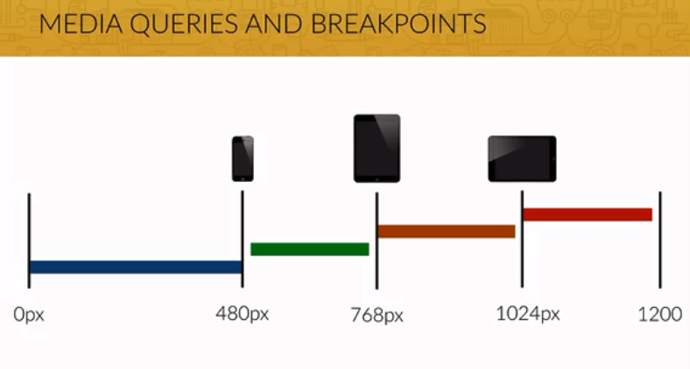

# Browser Support

CSS3 browser prefixes are a way for browser makers to add support for new CSS features in a kind of testing period.

Here are CSS browser prefixes for different browsers.

* Android: -webkit-
* Chrome: -webkit-
* iOS: -webkit-
* Safari: -webkit-
* Firefox: -moz-
* Internet Explorer: -ms-
* Opera: -o-

# Favicons

* Favicons are those little icons you see on browser tabs and on your bookmarks bar.
* It is part of the identity of any website and makes users recognize your website.
* There are online tools like Favicon Generator with which we can create icons for the browser, for the iOS home screen, for Android home screen, and for Windows 8, Windows in general.

# Optimizations

## Speed Optimizations

1. Optimize heavy images that's because images are usually the more heavy content of any webpage.
   1. First step we can reduce the actual dimension of the images.
   2. Use chrome developer tools to know what the actual images size used on the website is.
   3. The image size to be always twice as much as the actual size. And there's a simple reason for that, and it is high resolution displays. And those high resolution displays, like the retina displays we have on MacBooks, and iPhones, and also on your smartphones, need the image files to be larger than they appear on the screen in order to make them look super sharp.
   4. Use online image compressor/optimization tools to reduce image sizes.
2. Minify CSS and jQuery code.
   1. removing unneeded wide space and optimizing code.

## Search Engine Optimizations

It's so incredibly important that your website can be found by your users using a search engine like Google.

Basically Search Engine Optimization or CEO is a couple of techniques that improve and promote a website to increase the number of visitors the site receives from search engines.

There are many, many aspects to CEO, but here are some basics.

### Meta description tags

* This tag is a short description of a website and is normally used to describe a website on the search results page.
* It helps you to advertise for your site, drawing users to your website from the search results.
* It is, therefore, an extremely important part of search marketing, so we should craft compelling description using important keywords, but with no more than 160 characters.

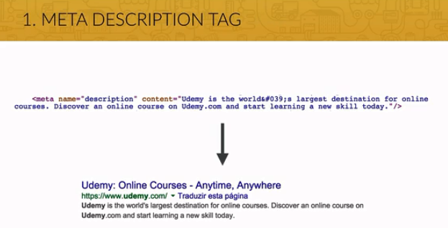

### Write Valid HTML code

* We should always write valid HTML code, and valid HTML code is code that follows exactly the official HTML rules and has no bugs.
* Valid HTML is preferred by Google, it makes websites more likely to work in browsers we haven't tested.
* It looks more professional, and it's better for accessibility, making it easier for screen readers to read websites to blind users, for instance.
* There is an official tool for checking if we have valid HTML code.  
  <https://validator.w3.org/>

### Content is King

* It's very important that you have great content on your website.
* Even if your website is on top of the search results, if the content is not great, and your users don't want to read it, then it's worth nothing that you're so high ranked.
* Also, keep providing new content if you can, so your visitors want to keep coming back for more.

### Keywords

* Place keywords strategically in your content.
* This is a key to perform well in search rankings, because keywords are what users actually use to find you. But be careful, don't overuse keywords, since search engines consider that as keyword spamming and might penalize you.
* Use keywords in the title, in the meta description tag, in your headings, and links.

### Backlinks

* Get other websites to link to you.
* These links are called backlinks and are like letters of recommendation for your website.
* Search engines rank websites based partially on the number and the quality of links that point to the site.
* You should have a strategy to increase the quantity and quality of backlinks to your site.

# Launch our Website

1. First, we need to choose and buy a domain name (from domain registration companies).
2. Then we need to buy web hosting/space (from web hosting companies).   
   Think of that as a folder in the internet where we'll put all our files.
3. Once we have both of those things, we just need to upload our website to our web space.
4. E.g. GoDaddy.com – Domain registration and Web hosting company.

# Site Maintenance

* Keep track of your website's success and monitor users' behavior.
* Use Google Analytics tool –

With this software, you'll be able to monitor statistics, like the number of visits your website receives, the amount of time your visitors stay, the average number of page views for each visitor, and many many other useful statistics.

* Using this data, you can make adjustments to the website in order to make it better and better.

# CSS Flexbox

Flexbox is an amazing new technology that allows us to lay out elements in a one dimensional row without using floats or other “hacks” (clearfix) like that.

It makes it so easy to place elements exactly where we want them to be with just a very small amount of code, making Flexbox perfect for building small page components like navigation or carts.

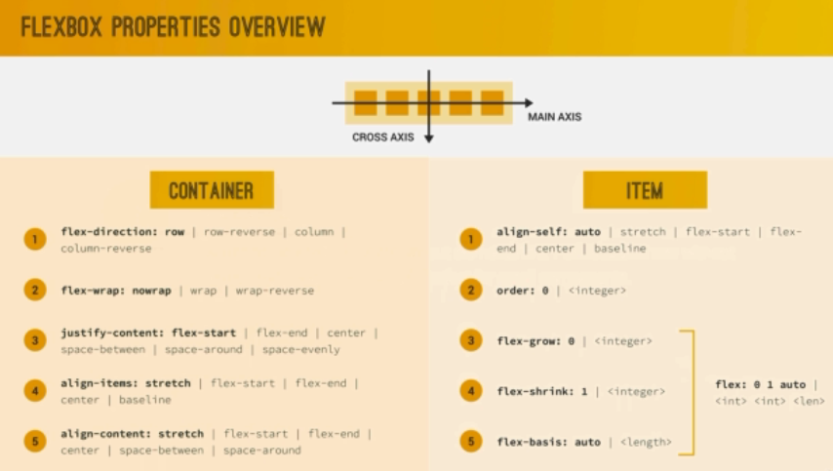

# CSS Grid

It's an even more cutting edge technology that we use to lay out elements in a fully fledged two dimensional grid, and some people say it's a bit like tables, but it's actually much more powerful than that. So since we can use a real two dimensional grid, CSS grid is absolutely perfect for building big overall page layouts and more complex components. Again, with a lot less CSS code and even HTML code than before.

# Improve Website Conversion Rate

Do you want to sell something on your website? Maybe a digital product like a course, or an e-book, or maybe a subscription plan? Here are some guidelines to actually improve your website conversion rates.

1. You can offer your visitors a **free gift** in order to build trust, instead of trying to sell anything right away. A very popular choice is to give away an e-book for free. If the user likes your book, he is more likely to buy anything from you after that.
2. **Repeat your primary action**

You should have a strong call to action button on your website, where you want your users to click. But instead of showing it just once, you should repeat it in more places on your website.

The more often the better, but obviously without spamming and frustrating the user.

1. **Grab your user’s attention.**

If possible instead of signup form on the website, use pop-up box for signup. Very effective.  
Though pop-up boxes can be quite annoying for the user, but they are still so popular because they actually convert so well, which means that they do work.

1. **Tell your user the benefit.**  
   In your call to action button, you need to tell your user the benefit of clicking that button. This is extremely important.  
   Instead of saying something boring like, 'Click Here' or 'Sign-Up', they tell the user he should try the service for free. That works much better. So always use a word which describes the benefit the user will get by clicking a button.
2. **Don’t ask for too much of information than you need.**  
   If you don't need phone numbers, address, or whatever, don't ask them for the information.

The user doesn't want to go through too many fields in a form to achieve something.

So forms with fewer fields definitely convert better.

1. **Use Social proof**  
   Social proof is a great persuasion tactic that can really help you increase conversion rates.

This can be done in form of customer testimonials, if you have any, or showing that other companies use your product or service. This this tactic is so incredibly effective because customers are actually more likely to trust others than to trust you. So use this whenever you can.

1. **Use Urgency**  
   Urgency is when a buyer feels like they need to act quickly and it's used in order to make people act now rather than later. E.g. “Limited Time available”, “Over 320 people bought this.”  
   You can use words like, 'now', 'hurry', 'instant', and 'immediately' in your call to action buttons, in order to make users act. This technique, together with that very big and clear call to action button, is extremely effective.
2. **Use Scarcity**  
   Scarcity is the feeling that a product or service is in short supply and about to run out.

And when there is less of anything, we actually tend to value it more. So this technique is also used to make the user act and buy something now before it runs out.

# BEM (Block, Element, Modifier) methodology

The Block, Element, Modifier methodology (commonly referred to as BEM) is a popular naming convention for classes in HTML and CSS. Its goal is to help developers better understand the relationship between the HTML and CSS in a given project.

e.g.

/* **Block** component */  
.btn {}

/* **Element** that depends upon the block */   
.btn__price {}

/* **Modifier** that changes the style of the block */  
.btn--orange {}   
.btn--big {}

In this CSS methodology a **block** is a top-level abstraction of a new component, for example a button: .btn { }. This block should be thought of as a parent.

Child items, or **elements**, can be placed inside and these are denoted by **two underscores** following the name of the block like .btn__price { }.

Finally, **modifiers** can manipulate the block so that we can theme or style that particular component without inflicting changes on a completely unrelated module. This is done by appending **two hyphens** to the name of the block just like btn--orange.

<a class="btn btn--big btn--orange" href="https://css-tricks.com">  
 <span class="btn__price">$9.99</span>  
 <span class="btn__text">Subscribe</span>  
</a>

If another developer wrote this markup, and we weren’t familiar with the CSS, we should still have a good idea of which classes are responsible for what and how they depend on one another.